Background
Decisive battle fought as part of Napoleonic Wars
Napoleonic wars fought between 1793 and 1815.
France, led by Napoleon Bonaparte, fought series of battles with other European countries.
Napoleon used time after Peace of Amiens (1802) to build up invasion force that would end British control of the seas.
Aims were to protect French sea trade and gain further control of European countries
Trafalgar 1805, great naval victory, though Britain suffered loss of its hero, Nelson

After Amiens…

Peace of Amiens breaks down in 1803. For most of next two years Britain waited to see what the French navy would do.
French fleet, led by Villeneuve, followed to West Indies by British fleet led by Admiral Horatio Nelson. When the Spanish failed to join French they returned to find shelter at port of Cadiz in September 1805

Late 1804, Spain joins the war on France’s side

French ships kept in port, prevented from leaving by British ships that were blockading them

Napoleon ordered French ships to escape from ports and head for West Indies (far away from the English Channel)
Napoleon wanted to gain control of English Channel so he could invade England more easily.

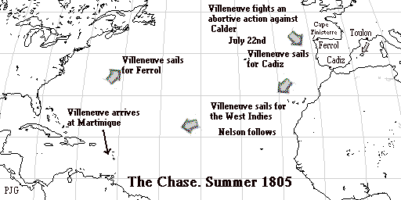

Nelson joined his fleet off Cadiz in late September
Nelson’s presence inspired British sailors
Nelson explained his battle plan to fleet commanders at his table of HMS Victory. ..\History Admin\1750-1900\Trafalgar\Battle plan picture.docxAdmin\1750-1900\Trafalgar\Nelson plan of attack.gif
Aim of plan was to destroy French fleet should they choose to leave port of Cadiz
Plan was for Nelson to lead the first column into attack and destroy enemy flagship, leaving opponents without a leader
Admiral Cuthbert Collingwood to lead second column that would wipe out the remaining French ships

Page 2
The Battle Plan
French fleet leaves Cadiz to engage in battle 21st October 1805
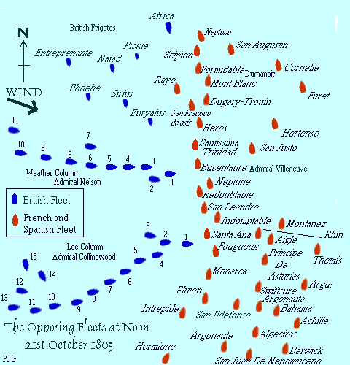

Some of Victory’s crew killed including John Scott, who was cut in half. Nelson and Captain Hardy almost injured

Nelson walked round ship. Issued signal, ‘England expects every man will do his duty’

England Expects…

Enemy reverses course, heading back to Cadiz, line confused.

As Victory approached enemy she was fired upon but could not reply because she was sailing at right-angles to the enemy so that she could attack the enemy ship from behind, rather than side-on, as was normally expected.

Ships now near Cape Trafalgar
Nelson waited for Villeneuve to show his flag so he would know where to attack

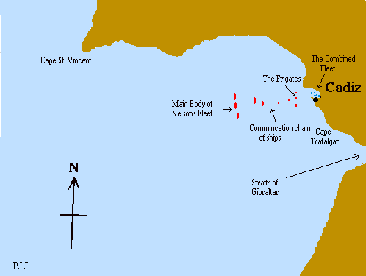

The Battle
12.35p.m. Victory in position to fire, under the stern of the French flagship, the Bucentaure
Broadside from Victory kills 200 men. Admiral Villeneuve only man left standing on the Quarter deck.
Victory now stuck in middle of enemy fleet but had trapped Villeneuve on a crippled ship, unable to lead his fleet
1.15 p.m. Nelson hit by lead musket ball which cut an artery and lodged in his spine. Nelson taken to ship’s surgery

Page 3
Battle raged on. Faster and more effective British gunnery wore down enemy. Over next three hours Franco-Spanish force would collapse.
Despite fact that main part of battle had seen 12 British ships fighting 22 enemy ships, brilliant tactics had helped win the day. British ships were faster and when weakening, supported by later wave of vessels.
Conclusion
At 2.15 p.m. Villeneuve surrendered. Battle continued until victory was finally confirmed at 3.30 p.m.
Nelson died shortly before 4.30.p.m.
1700 British killed or wounded. 6000 enemy casualties, nearly 20,000 prisoners taken.
Whilst Britain lost a national hero, his genius had prevented the planned French invasion and the French and Spanish fleets had been destroyed.
Britain’s control of the seas set limits to Napoleon’s Empire and plotted the course of his downfall.
The victory at Trafalgar, inspired by Nelson, settled the command of the seas for a century.

