Soufriere Hills volcanic eruption, Montserrat, 1995
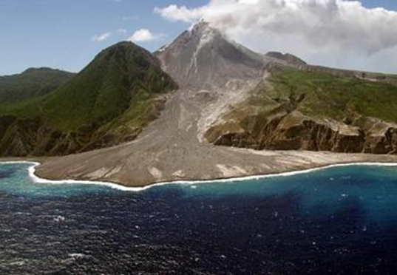
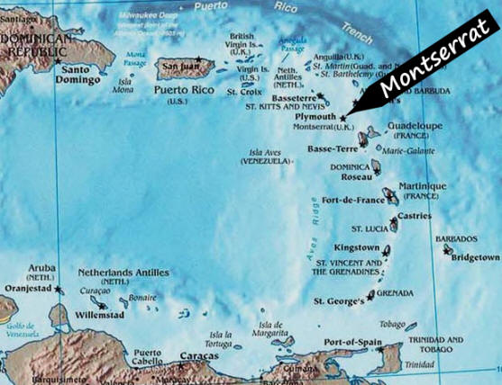
Environmental Effects
- Ash covered 2/3 of the Island
- Wildlife disappeared
- Pyroclastic flow burned vegetation
- New land was formed when the pyroclastic flow solidified into the sea
- Coral reef and sea creatures died from that ash that washed into the sea
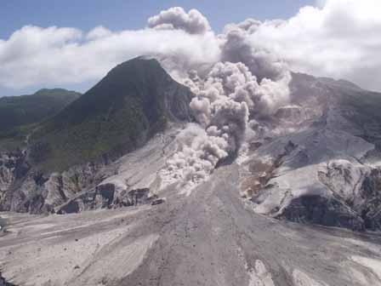

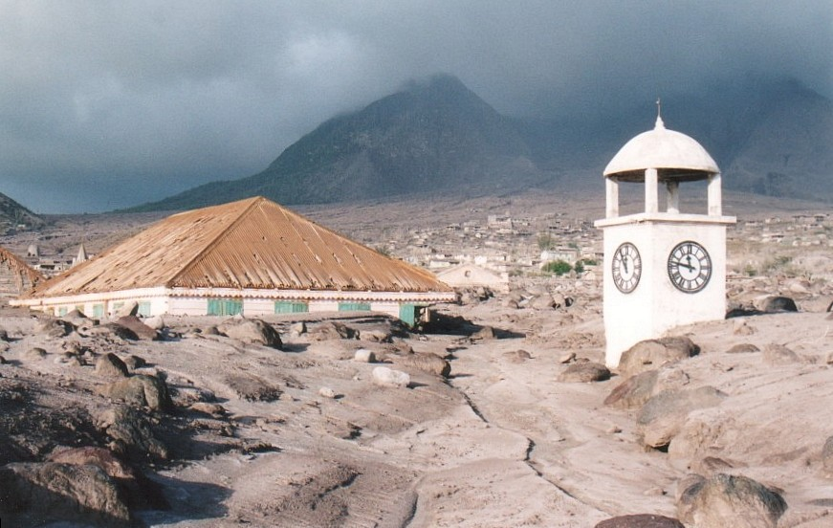

Economic Effects
- Ruined the tourist economy
- The agricultural economy was ruined
- The airport was closed for 10 years

Social Effects
- 8000 inhabitants left Montserrat for the UK and Antigua
- Hospitals were destroyed
- 60% of housing was destroyed
- 23 people died in the pyroclastic flow
- Few schools were left intact
- There was a lack of clean water and sewerage facilities
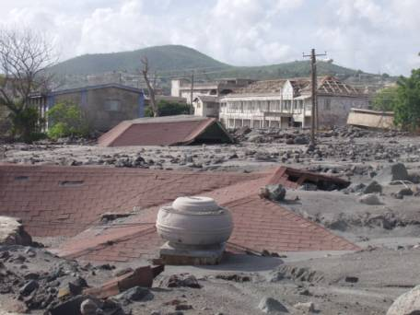

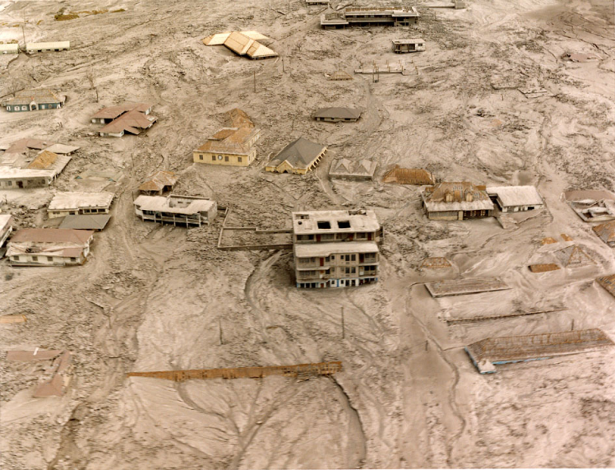
Human responses
- The Montserrat volcano observatory was built to monitor the volcano with seismometers and tiltmeters
- A hazard map was drawn up to highlight danger and safe zones
- International aid was received from the UK and other countries

Human responses (cont.)
- Inhabitants were evacuated to the UK and Antigua
- There was a concert in the Royal Albert Hall to raise money. The money allowed the UK to send out HMS Liverpool with emergency showers and kitchen facilities for the Islanders

