Japanese (Sichuan) Earthquake and Tsunami
Causes
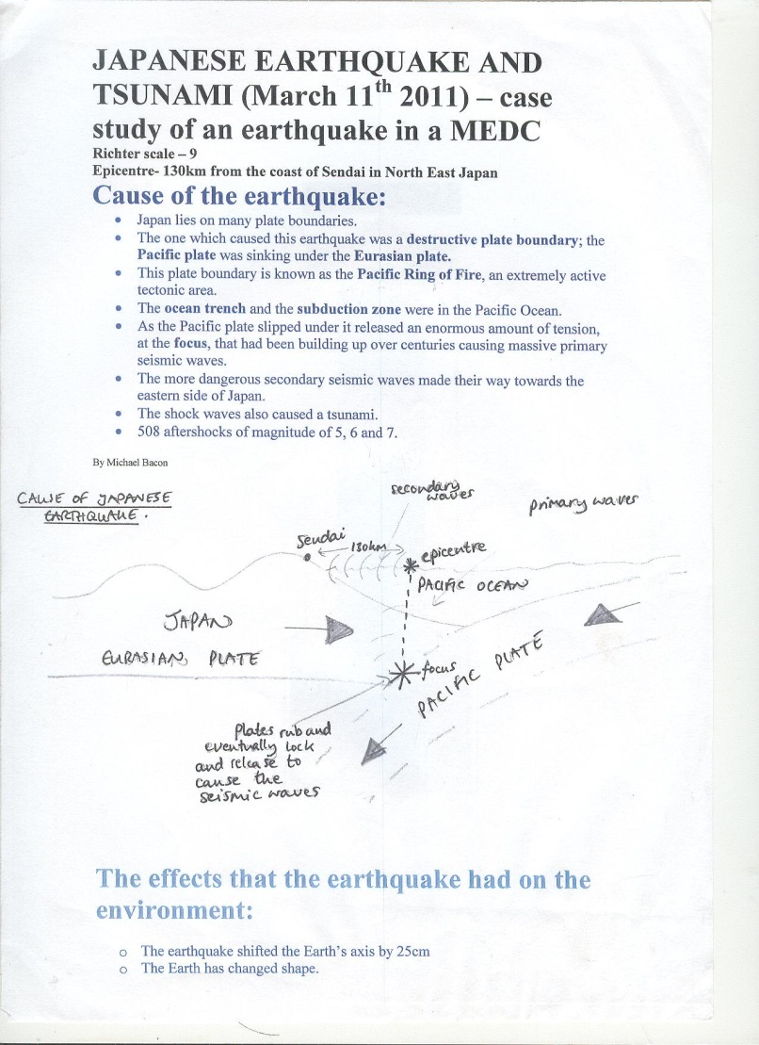
- On a destructive plate boundary between the Eurasian and Pacific plates (On the Pacific Ring of Fire)
- The ocean trench and subduction zone were in the Pacific Ocean which also set of a huge tsunami
- The plates had been building up friction over time and then slipped which relseased hige amounts of tensions and seismic waves
- The earthquake was 9.1 on the Richter scale
Response
Immediate/ Primary:
- Mobile phone messages were sent out to everyone to warm them of the earthquake and tsunami hazards and get to high ground. One minute until the earthquake and 20minutes until the tsunami. Drills were put in to place
- The Hawaii Pacific earthquake facility sent warnings to other Pacific islands to warn them
- Lots of data was collected about the earthquake and movements of the plates
- Tsunami flood gate/ wall was closed
Secondary:
- Aid was given by many different countries including the UK
- Emergency services, the army and aid agencies were sent in to help the clear up effort including ‘Save the Children’ and ‘Oxfam’
11th March 2011
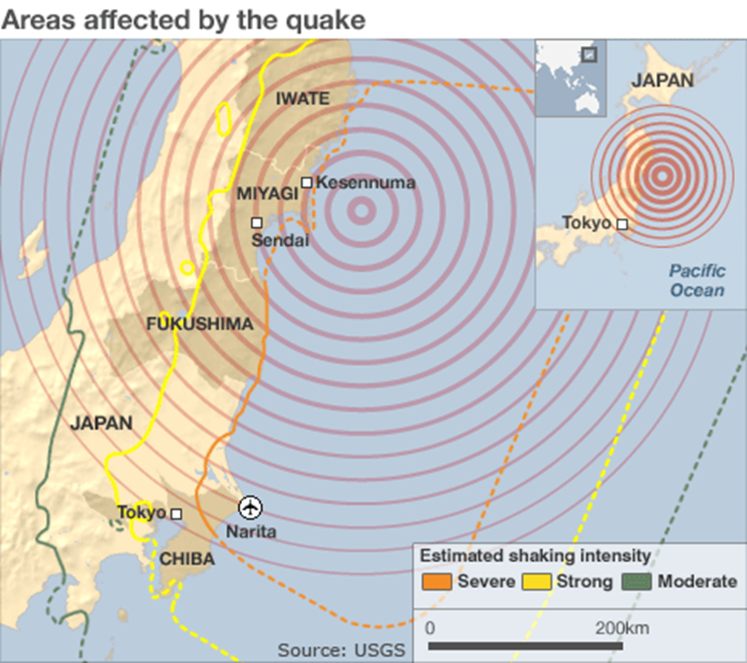
Social and Economic Effects
- 15,000 people died and 5000 went missing presumed dead
- Fukushima nuclear power plant leaked radiation which affected peoples health
- The airport was destroyed and large areas were without power
- Schools and hospitals destroyed. In some regions 50% of the population and 95% of the buildings were destroyed
- A secondary affect was the depression after and the diseases that spread as well as the fires due to gas leaks
Environmental Effects
- The earth shifted 25cm on its axis
- The coast of Japan moved 3m out to see and parts of the coast dropped 1m
- The Fukushima nuclear power plant was impacting causing threats to the local area
- Liquefaction occurred which damaged the ground and habitats
- 10 billion tonnes of water spread out across Japan after the tsunami which damaged homes and habitats

