Denbies
Reason for the location of Denbies
- The slopes are south facing so get the sun and are protected from cold Northerly winds- good for growing grapes
- The chalk geology means the soil is well drained- perfect for the growing of vines as they do not like to be water logged
- The soil type is like that in the champagne region, so sparkling wine grapes grow well here.
- Near to Dorking which provides the labour and business
- Near to good transport route like the M25 for access and exporting goods
Inputs, Processes, Outputs and Feedback/Linkages
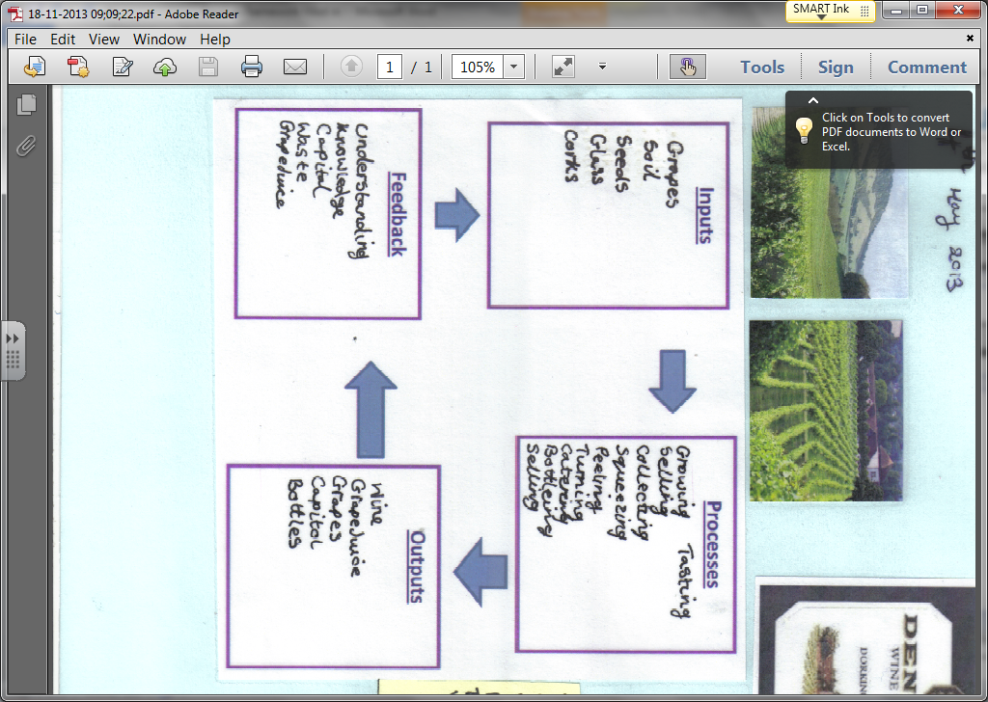
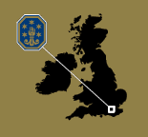
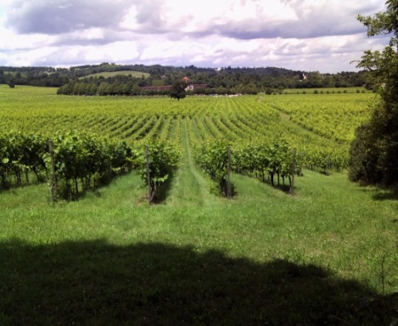
Positives to the local area
- Provides jobs for the local area which boost the economy
- People who have shops, restaurants and hotels in the local area may benefit from increased business from people in the area
- Local roads are maintained to ensure people and goods can get in and out of Denbies
- Walking route and footpaths are maintained in the site

Negatives to the local area
- Pollution can be caused by the big burners that are used to keep the vines warm
- Soil and fertilisers and leech into the river below causing eutrophication and clog up the river
- Congestion can be a problem at peak times and large lorries can take up the roads

